VBA Challenge Homework

by Leanne Thompson, 3/19/21

Screenshot of 2014

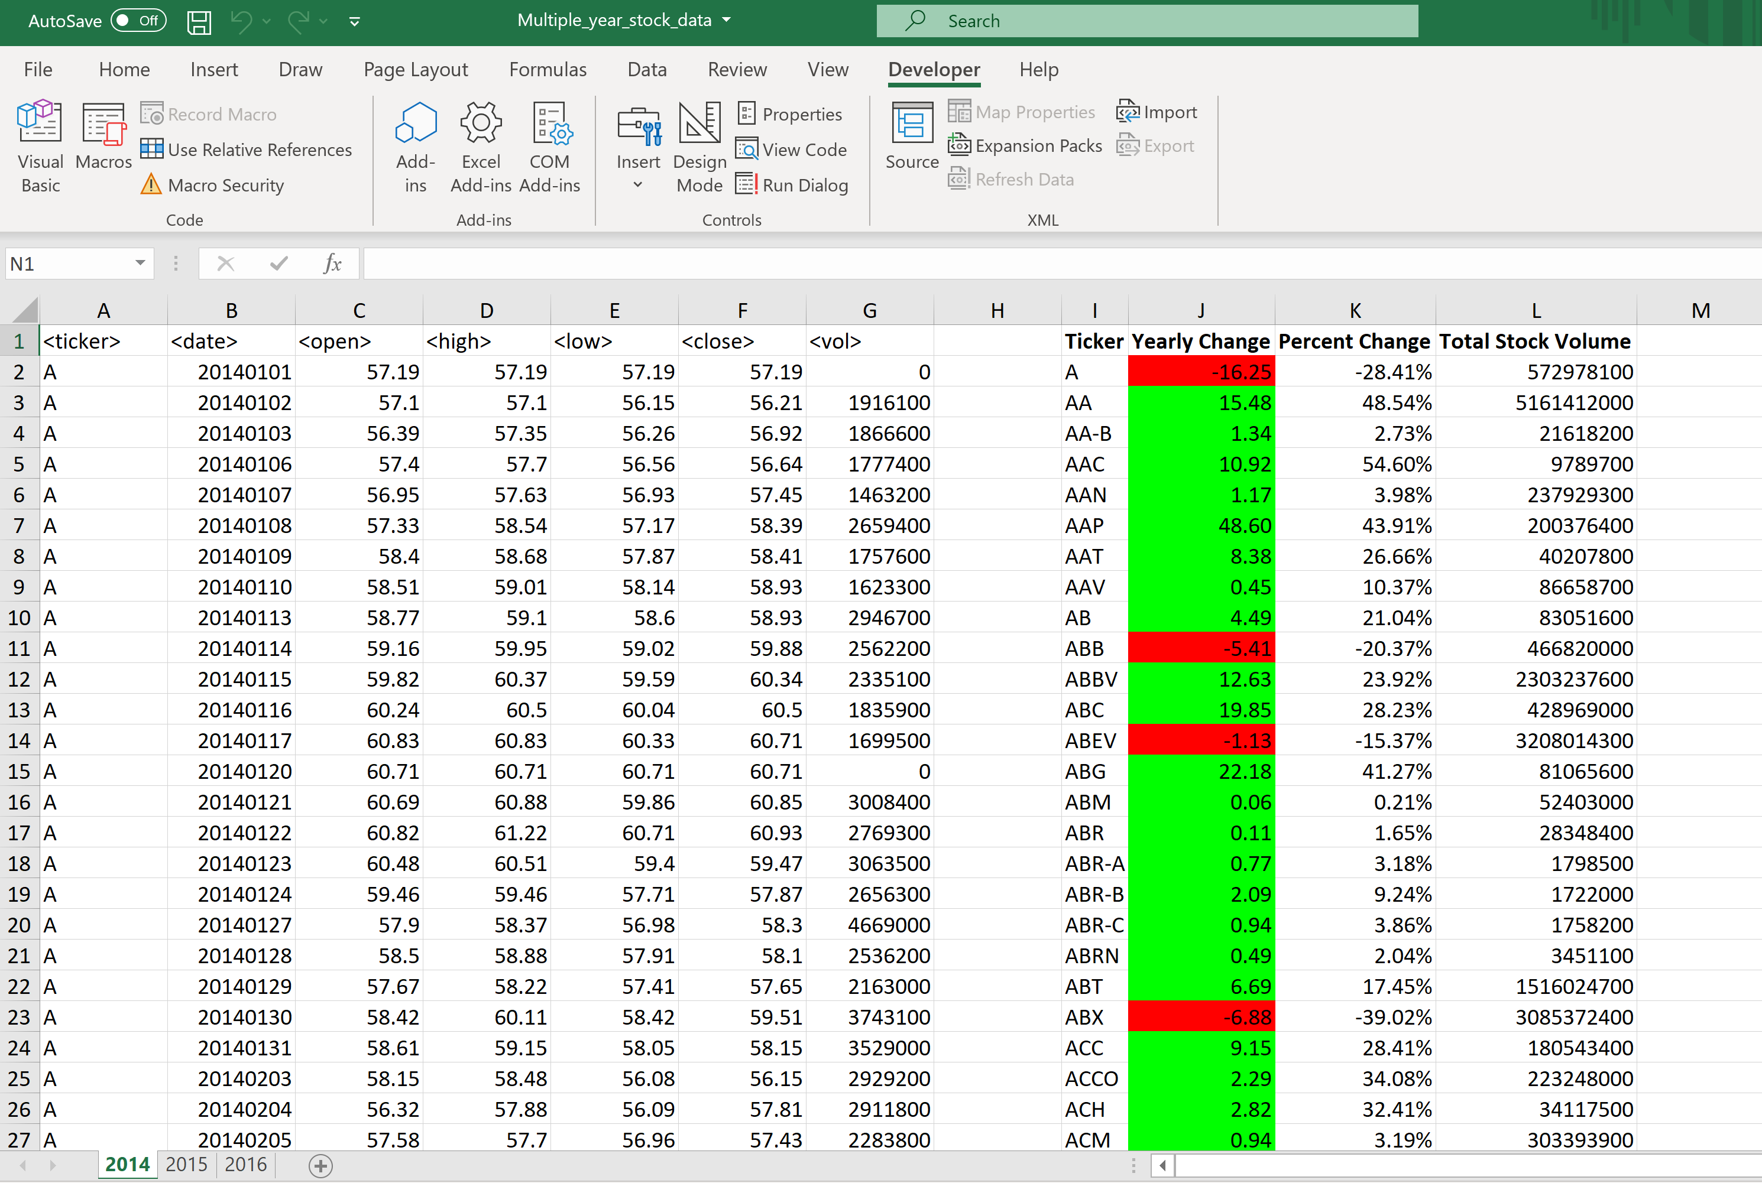

Screenshot of 2015

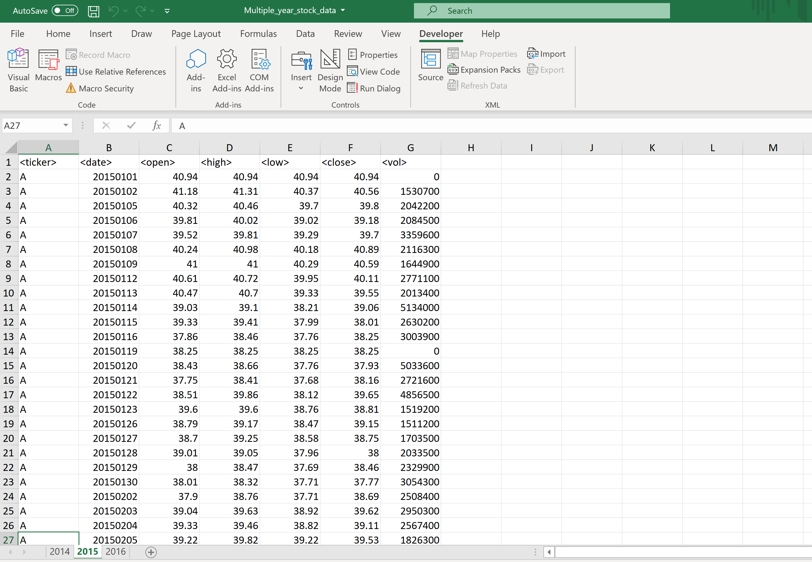

Screenshot of 2016

